DESIGN AND ANALYSIS OF ALGORITHMS
Brute Force Closest Pair and Convex Hull
SDG 4 – Quality Education Application

1. Executive Summary
This project converts a classical Design and Analysis of Algorithms exercise into a student-friendly real-world case study. The application is an education-facility planning system connected to SDG 4 – Quality Education. Each school or learning centre is represented by a two-dimensional coordinate. The Closest Pair algorithm finds the two nearest facilities, while the Convex Hull identifies the outer boundary of the set of facilities. Both problems are first solved using Brute Force so that the logic is easy to understand. The document then explains how Divide-and-Conquer and Hybrid methods improve scalability.
Main result for the supplied dataset: 45 unordered point pairs are checked for Closest Pair, and the nearest pair is (9, 4) and (7, 2) with distance 2.828. The convex hull vertices are (1, 7) → (2, 3) → (7, 2) → (15, 6) → (10, 14) → (3, 11).

2. Assignment Requirements
The uploaded assignment asks for an analytical study and implementation of Brute Force Closest Pair and Convex Hull problems. It specifies a 10-point set, asks for algorithms/pseudocode, intermediate calculations, graphical representation, complexity analysis, comparison of approaches, and an experimental study using public coordinate data for input sizes from 10³ to 10⁶. It also maps the work to SDG 4 and SDG 9.
The assignment also expects problem analysis, both algorithms, step-by-step calculations, results, graphs, complexity, comparative analysis and a final conclusion.

3. Real-World Problem Scenario

3.1 Scenario: Education Facility Accessibility
Imagine a district education department maintaining the locations of government schools, libraries, community learning centres and digital-learning hubs. Each facility has a geographic location. Before making planning decisions, the department may need to understand how facilities are distributed.
Example questions:
- Which two learning facilities are closest to each other?
- Which facilities form the outer geographic boundary of the current education network?
- How does the algorithm behave when the number of facilities grows from 10 to thousands or millions?
- Can a faster algorithm be used when the data becomes too large for Brute Force?

3.2 Link to SDG 4
SDG 4 is represented in this project through the idea of using data and algorithms to support better planning of learning infrastructure. The algorithm does not itself measure education quality. Instead, it is a computational tool that can support spatial analysis of education facilities.

3.3 Link to SDG 9
SDG 9 relates to industry, innovation and infrastructure. Efficient algorithms are part of the digital infrastructure needed to process large spatial datasets.

4. Why Algorithms Are Needed
If there are only 10 facilities, checking every pair manually is possible. If there are 100,000 facilities, however, the number of pairs becomes enormous. Therefore, algorithm design matters. A correct algorithm should not only produce the right answer; it should also use time and memory efficiently.
Simple idea:
Small dataset → Brute Force is easy to understand.
Large dataset → efficient algorithms become necessary.
Very large dataset → scalability becomes a major design requirement.

5. Dataset and Data Representation
The assignment supplies the following 10 points:
Point | X | Y
P1 | 2 | 3
P2 | 5 | 8
P3 | 9 | 4
P4 | 12 | 10
P5 | 7 | 2
P6 | 3 | 11
P7 | 15 | 6
P8 | 10 | 14
P9 | 6 | 12
P10 | 1 | 7

5.1 Education Interpretation
For this case study, P1–P10 are treated as 10 education facilities. The numbers are synthetic coordinates supplied for algorithm demonstration, so they should not be reported as actual school locations.

5.2 Dataset Preprocessing for Real GIS Data
- Remove records with missing or invalid coordinates.
- Remove accidental duplicate records when they represent the same facility.
- Use one coordinate reference system.
- For small local analysis, convert latitude/longitude to an appropriate planar coordinate system before applying Euclidean distance.
- Keep facility ID and other attributes so algorithmic results can be linked back to real facilities.

6. Mathematical Background

6.1 Euclidean Distance
For A(x1,y1) and B(x2,y2):
d(A,B) = √[(x2 − x1)² + (y2 − y1)²]
For programming, compare d² instead of d when only the smallest distance is required. This avoids unnecessary square-root operations.

6.2 Orientation / Cross Product
For A, B and C:
orientation(A,B,C) = (Bx−Ax)(Cy−Ay) − (By−Ay)(Cx−Ax)
Interpretation:
- positive → C lies on one side of directed AB
- negative → C lies on the other side
- zero → A, B and C are collinear

7. Closest Pair – Brute Force
Brute Force means we do not try to be clever. We simply compare every possible pair of points and keep the smallest distance found so far.

7.1 Student-Friendly Algorithm
- Start with minimum distance = infinity.
- Select the first point.
- Compare it with every point after it.
- Store the smallest distance found.
- Move to the next point and repeat.
- After all pairs are checked, report the stored pair.

7.2 Pseudocode
ALGORITHM ClosestPairBruteForce(P)
Input: n points P[1...n]
Output: closest pair and minimum distance
minDist ← ∞
bestPair ← NULL
FOR i ← 1 TO n−1
FOR j ← i+1 TO n
dx ← P[i].x − P[j].x
dy ← P[i].y − P[j].y
d2 ← dx² + dy²
IF d2 < minDist² THEN
minDist² ← d2
bestPair ← (P[i], P[j])
END IF
END FOR
END FOR
RETURN bestPair, √minDist²

8. Closest Pair – Step-by-Step Example
There are n=10 points. The number of unordered pairs is:
C(n,2) = n(n−1)/2 = 10×9/2 = 45 comparisons.
Pair | dx | dy | d² | d
(2, 3)–(5, 8) | -3 | -5 | 34 | 5.831
(2, 3)–(7, 2) | -5 | 1 | 26 | 5.099
(5, 8)–(6, 12) | -1 | -4 | 17 | 4.123
(9, 4)–(7, 2) | 2 | 2 | 8 | 2.828
(12, 10)–(10, 14) | 2 | -4 | 20 | 4.472
After all 45 comparisons, the minimum squared distance is 8. Therefore the closest pair is (9, 4) and (7, 2), with distance √8 = 2.828.

9. Convex Hull – Brute Force
The Convex Hull is like stretching a rubber band around all the points. The points touched by the rubber band form the outer boundary. Points completely inside the boundary are not hull vertices.

9.1 Student-Friendly Idea
- Take two points and pretend the line joining them is a boundary edge.
- Check every other point.
- If all other points are on the same side of the line, the pair can be a hull edge.
- Repeat for every pair.
- Join the valid boundary edges to form the hull.

9.2 Pseudocode
ALGORITHM ConvexHullBruteForce(P)
Input: n points
Output: hull edges / hull vertices
edges ← empty set
FOR every pair of points (i,j)
positive ← FALSE
negative ← FALSE
FOR every point k except i and j
s ← orientation(P[i],P[j],P[k])
IF s > 0: positive ← TRUE
IF s < 0: negative ← TRUE
END FOR
IF positive = FALSE OR negative = FALSE
add (P[i],P[j]) to edges
END IF
END FOR
Order the hull edges around the boundary
RETURN hull

10. Convex Hull – Step-by-Step Explanation
Suppose we test an edge AB. For every other point C, calculate the orientation value. If the signs never contain both positive and negative values, all points lie on one side of AB or on AB itself. Therefore AB is a supporting edge of the convex hull.

10.1 Hull Result for the Dataset
The hull vertices are:
(1, 7) → (2, 3) → (7, 2) → (15, 6) → (10, 14) → (3, 11) → (1, 7)
The other points are inside the hull and therefore do not form the outer boundary.
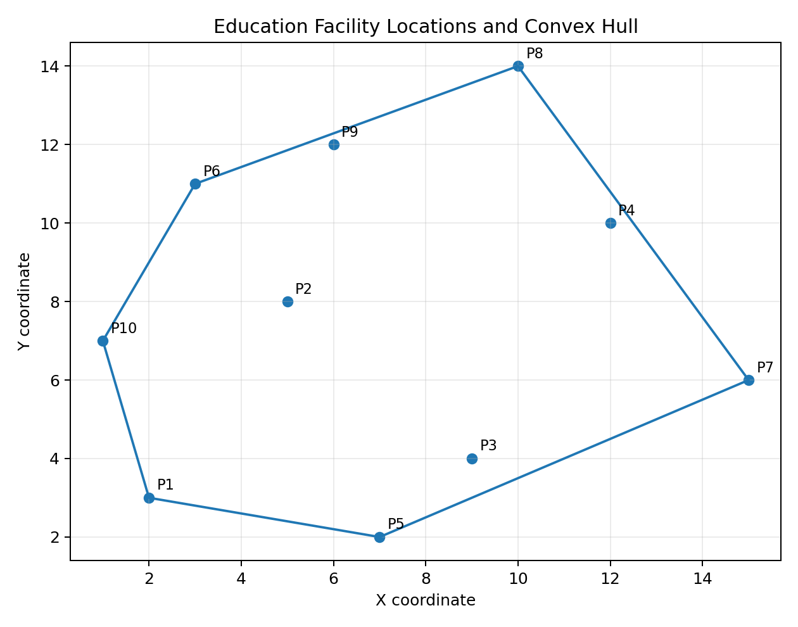
Figure 1 – Education facility points and Convex Hull.

11. Python Implementation

11.1 Complete Program
import math
points = [(2,3),(5,8),(9,4),(12,10),(7,2),(3,11),(15,6),(10,14),(6,12),(1,7)]
def closest_pair(points):
best = float('inf')
pair = None
for i in range(len(points)):
for j in range(i+1, len(points)):
d2 = (points[i][0]-points[j][0])**2 + (points[i][1]-points[j][1])**2
if d2 < best:
best = d2
pair = (points[i], points[j])
return pair, math.sqrt(best)
def orientation(a,b,c):
return (b[0]-a[0])*(c[1]-a[1]) - (b[1]-a[1])*(c[0]-a[0])
def convex_hull_bruteforce(points):
edges=[]
n=len(points)
for i in range(n):
for j in range(i+1,n):
pos=neg=False
for k in range(n):
if k==i or k==j: continue
s=orientation(points[i],points[j],points[k])
pos |= s>0
neg |= s<0
if not (pos and neg):
edges.append((points[i],points[j]))
return edges
pair, distance = closest_pair(points)
print('Closest pair:', pair)
print('Minimum distance:', round(distance,3))
print('Hull edges:', convex_hull_bruteforce(points))

12. Program Output and Interpretation
Expected key output:
Closest pair: (9, 4) and (7, 2)
Minimum distance: 2.828
Number of distance comparisons: 45
Interpretation: the program systematically checks all possible pairs. Because no pair is skipped, the final minimum is guaranteed to be correct for the supplied dataset.

13. Graphical Analysis

13.1 Coordinate Plot
The first graph shows all education-facility points and connects the outer hull vertices.

13.2 Theoretical Complexity Graph
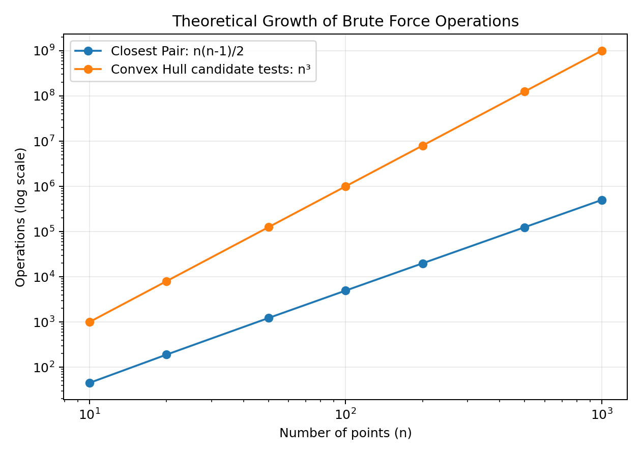
Figure 2 – Theoretical operation growth. Values are calculated from the complexity formulas, not measured runtime.
The graph shows why Brute Force becomes expensive. Closest Pair grows quadratically, while the simple candidate-edge Convex Hull method grows cubically.

13.3 Brute Force vs Divide-and-Conquer Growth
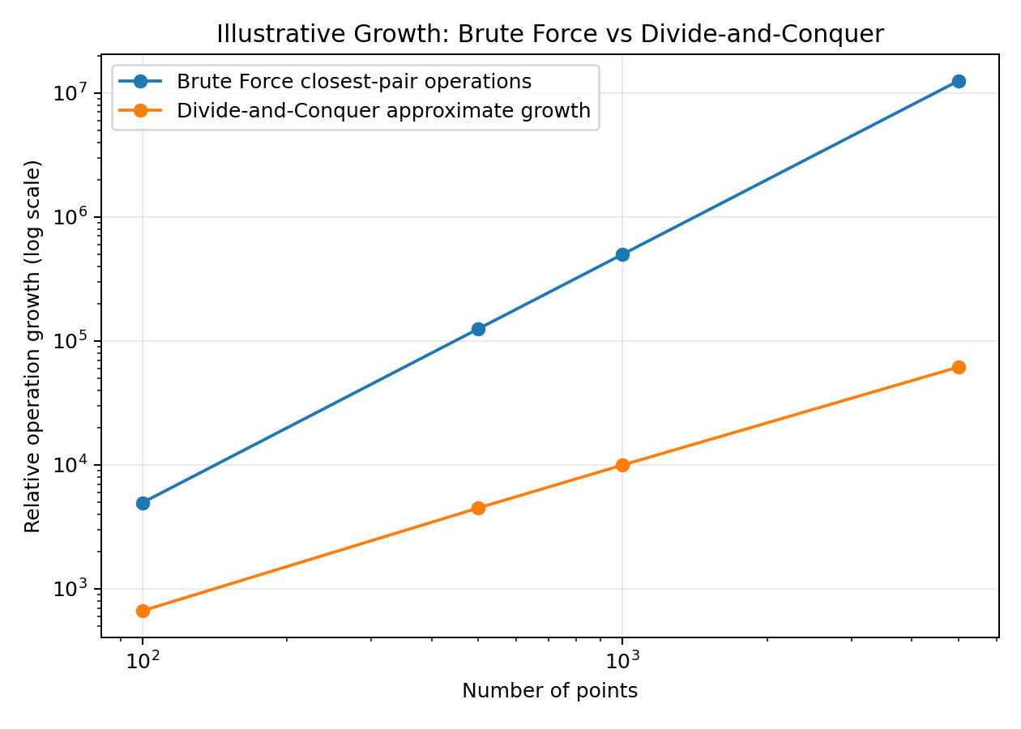
Figure 3 – Illustrative operation-growth comparison; this is not a benchmark result.

14. Complexity Analysis
Method | Time | Extra Space | Reason
Closest Pair – Brute Force | Θ(n²) | Θ(1) | C(n,2) pair checks
Closest Pair – Divide-and-Conquer | Θ(n log n) | Θ(n) typical | Split into halves and process a strip
Convex Hull – Brute Force | O(n³) | O(n) typical | O(n²) candidate pairs × O(n) side tests
Efficient Convex Hull | O(n log n) | O(n) | Sorting + orientation-based construction

14.1 Why n Matters
- n=10: Closest Pair pair count = 45.
- n=100: Closest Pair pair count = 4,950.
- n=1,000: Closest Pair pair count = 499,500.
- n=10,000: Closest Pair pair count = 49,995,000.

15. Large Dataset Experiment Plan
The assignment requires a publicly available real-world coordinate dataset and tests from 10³ to 10⁶ points. The uploaded brief does not provide a specific external dataset, so measured timings must be collected from the chosen public dataset rather than invented.

15.1 Recommended Dataset Structure
CSV columns:
facility_id, latitude, longitude, facility_type, region

15.2 Experiment Sizes
Input size | Purpose | Brute Force | Efficient/Hybrid
1,000 | Scalability test | Run if feasible | Run
5,000 | Scalability test | Run if feasible | Run
10,000 | Scalability test | Run if feasible | Run
50,000 | Scalability test | Run if feasible | Run
100,000 | Scalability test | Run if feasible | Run
500,000 | Scalability test | Run if feasible | Run
1,000,000 | Scalability test | Run if feasible | Run

15.3 What to Record
- Execution time in seconds
- Number of distance/orientation operations
- Peak memory if available
- Python version
- CPU/RAM
- Dataset preprocessing time
- Algorithm threshold for Hybrid

15.4 Fair Experimental Method
- Use the same machine for every algorithm.
- Use the same input points and ordering.
- Run each experiment multiple times and report average or median time.
- Do not include file-download time in algorithm runtime.
- Warm up the environment before timing.
- State when Brute Force is stopped because it is computationally impractical.
- Never present theoretical values as measured runtime.

16. Divide-and-Conquer Approach
Divide-and-Conquer reduces a large problem into smaller problems. For Closest Pair, points are sorted by x-coordinate, divided into left and right halves, and the closest pair is found recursively. A narrow strip around the dividing line is then checked for pairs that cross the split.

16.1 Student-Friendly Flow
Sort → Divide → Solve left → Solve right → Check middle strip → Return minimum

16.2 Why It Is Faster
Instead of comparing every point with every other point, the algorithm uses spatial structure to eliminate most unnecessary comparisons. Its standard time complexity is Θ(n log n).

17. Hybrid Approach
A Hybrid algorithm combines two strategies. For large problems it uses Divide-and-Conquer; when a subproblem becomes small, it switches to Brute Force. This avoids recursion overhead on tiny subsets.

17.1 Suggested Threshold
A practical experiment can test thresholds such as 8, 16, 32 and 64 and choose the best-performing value on the target machine. For the final submission, the actual chosen threshold and measured result must be reported.

17.2 Hybrid Pseudocode
ALGORITHM HybridClosestPair(P)
IF size(P) ≤ threshold THEN
RETURN ClosestPairBruteForce(P)
ELSE
divide P into left and right
leftResult ← HybridClosestPair(left)
rightResult ← HybridClosestPair(right)
check the middle strip
RETURN smallest result
END IF

18. Comparison of Algorithms
Feature | Brute Force | Divide-and-Conquer | Hybrid
Easy to understand | Excellent | Moderate | Moderate
Closest Pair complexity | Θ(n²) | Θ(n log n) | Usually near Θ(n log n)
Small datasets | Good | Good | Very good
Large datasets | Poor | Good | Very good
Implementation complexity | Low | Higher | Higher
Main idea | Check everything | Reduce the search | Use both strategies

19. SDG 4 and SDG 9 Mapping
SDG | Project Connection | Expected Learning
SDG 4 – Quality Education | Uses computational analysis in an education-facility planning scenario | Analytical thinking, programming and problem solving
SDG 9 – Industry, Innovation and Infrastructure | Demonstrates scalable spatial algorithms for digital infrastructure | Algorithm optimization and scalable computing

20. Advantages, Limitations and Assumptions

20.1 Advantages
- Simple logic
- Easy to verify manually
- Useful for small datasets
- Excellent for learning algorithm design
- Provides a baseline for comparing optimized algorithms

20.2 Limitations
- Quadratic Closest Pair cost
- Cubic brute-force Convex Hull cost
- Not suitable for millions of points in ordinary brute-force form
- Euclidean distance can be inappropriate for raw latitude/longitude over large areas
- Hull alone does not measure road travel time or education quality

20.3 Assumptions
- The 10 supplied points are synthetic classroom coordinates.
- A planar coordinate system is used when Euclidean distance is applied.
- Duplicate and invalid GIS records are handled during preprocessing.
- Experimental runtime results are measured separately and are not fabricated in this report.

21. Final Conclusion
This project shows the complete path from an algorithmic classroom problem to a real-world-inspired SDG application. The education scenario gives meaning to the coordinates: they represent learning facilities whose spatial distribution can be analysed. The Brute Force Closest Pair method checks all 45 pairs for the ten-point dataset and finds (9, 4) and (7, 2) as the nearest pair at distance 2.828. The Brute Force Convex Hull method tests candidate edges using orientation and identifies the outer boundary. Most importantly, the complexity analysis explains why an algorithm that is perfectly acceptable for 10 points cannot simply be scaled to millions of points. Divide-and-Conquer and Hybrid algorithms provide a path toward scalable implementations. This combination of algorithm design, implementation, visualization, experimental evaluation and SDG context makes the work suitable as a student project and classroom presentation.

22. References and Submission Checklist
The assignment brief supplied by the student is the primary source for the required problem, dataset, course outcome, SDG mapping and deliverables.
Before final submission, verify:
- Cover page completed with student name, register number and department.
- Python code executes without errors.
- Closest-pair output matches the documented result.
- Convex-hull graph is included.
- Real public coordinate dataset source and license are added if the 10³–10⁶ experiment is performed.
- Actual measured runtime and operation counts are inserted into the experimental table.
- Hybrid threshold is stated and justified by measurements.
- Graphs are labelled as measured or theoretical/illustrative.
- Assumptions and limitations are clearly stated.

